|  |  |  |  |  |
| --- | --- | --- | --- | --- |
| **ÁREA:** MATEMÁTICAS | | | **DOCENTE:** | |
| **ASIGNATURA:** MATEMÁTICAS | | | **ESTUDIANTE:** | |
| **GRADO:** CICLO VI | **MÓDULO: 2** | **ANEXO:** 01 | **TIEMPO:** | **FECHA: ____/ ____ / ____** |

**ACTIVIDAD 1**

1. Complete las siguientes tablas y, con base en ellas, determina si el límite propuesto existe o no existe.

$f\left(x\right)=2x^{2}-5x+1$

|  |  |  |  |  |  |  |
| --- | --- | --- | --- | --- | --- | --- |
| $$x$$ | 0,9 | 0,99 | 0,999 | 1,1 | 1,01 | 1,001 |
| $$f\left(x\right)$$ |  |  |  |  |  |  |

Tabla 3

$$\lim_{x→1}{{2x}^{2}-5x+1}$$

$g\left(x\right)=\frac{x^{2}-4}{x^{2}-5x+6}$

|  |  |  |  |  |  |  |
| --- | --- | --- | --- | --- | --- | --- |
| $$x$$ | 1,9 | 1,99 | 1,999 | 2,1 | 2,01 | 2,001 |
| $$g\left(x\right)$$ |  |  |  |  |  |  |

Tabla 4

$$\lim_{x→2}\frac{x^{2}-4}{x^{2}-5x+6}$$

$j\left(x\right)=\frac{2+\sqrt[3]{x}}{8+x}$

|  |  |  |  |  |  |  |
| --- | --- | --- | --- | --- | --- | --- |
| $$x$$ | -8.1 | -8.01 | -8.001 | -7.9 | -7.99 | -7.999 |
| $$j\left(x\right)$$ |  |  |  |  |  |  |

Tabla 5

$$\lim_{x→-8}\frac{2+\sqrt[3]{x}}{8+x}$$

$k\left(x\right)=\left\{\begin{aligned}\frac{x^{2}+3x}{2x-2}, si &x<-1 \\ 4x-5, si &x>-1\end{aligned}\right.$

|  |  |  |  |  |
| --- | --- | --- | --- | --- |
| $$x$$ | -2.01 | -2.001 | -1.99 | -1.999 |
| $$k\left(x\right)$$ |  |  |  |  |

Tabla 6

$$\lim_{k→-2}k(x)$$

1. Con base en la gráfica determine si los límites existen.

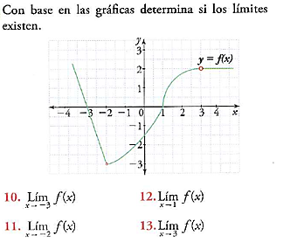

$$\lim_{x→-3}f(x)$$

$$\lim_{x→-2}f(x)$$

$$\lim_{x→1}f(x)$$

Gráfico 3

$$\lim_{x→3}f(x)$$

1. Con base en la gráfica determine si los límites existen.

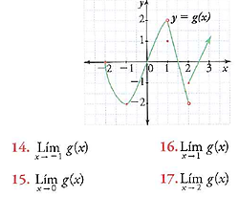

$$\lim_{x→-1}g(x)$$

$$\lim_{x→0}g(x)$$

$$\lim_{x→1}g(x)$$

Gráfico 4

$$\lim_{x→2}g(x)$$