|  |  |  |  |  |
| --- | --- | --- | --- | --- |
| **ÁREA: Humanidades lengua castellana e idioma extranjero** | | | **DOCENTE:** | |
| **ASIGNATURA:** Inglés | | | **ESTUDIANTE:** | |
| **GRADO:** BÁSICO | **NIVEL:** 1 | **ANEXO:** 2 | **TIEMPO:** | **FECHA: ____/ ____ / ____** |

**ACTIVITY 2**

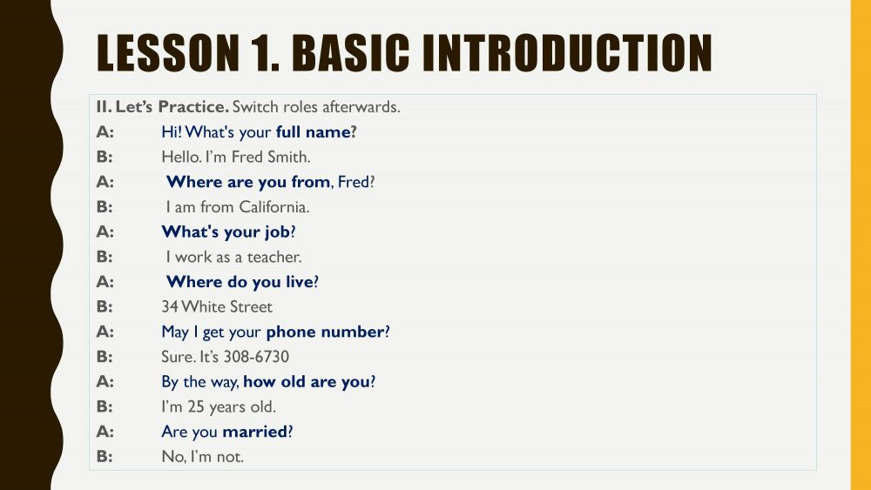

It´s important to **practice** this conversation; memorize the questions and answers and later do something similar with your own skills.

Picture 4 <http://11talk.net/portfolio/books-basic-english-conversation/>