|  |  |  |  |  |
| --- | --- | --- | --- | --- |
| **ÁREA: Humanidades lengua castellana e idioma extranjero** | | | **DOCENTE:** | |
| **ASIGNATURA:** Inglés | | | **ESTUDIANTE:** | |
| **GRADO:** BÁSICO | **NIVEL:** 1 | **ANEXO:** 3 | **TIEMPO:** | **FECHA: ____/ ____ / ____** |

**ACTIVITY 3**

**According to the picture; in association, write the Spanish form of the human body parts.** De acuerdo a la imagen y asociación; escribe las partes del cuerpo humano frente al numeral

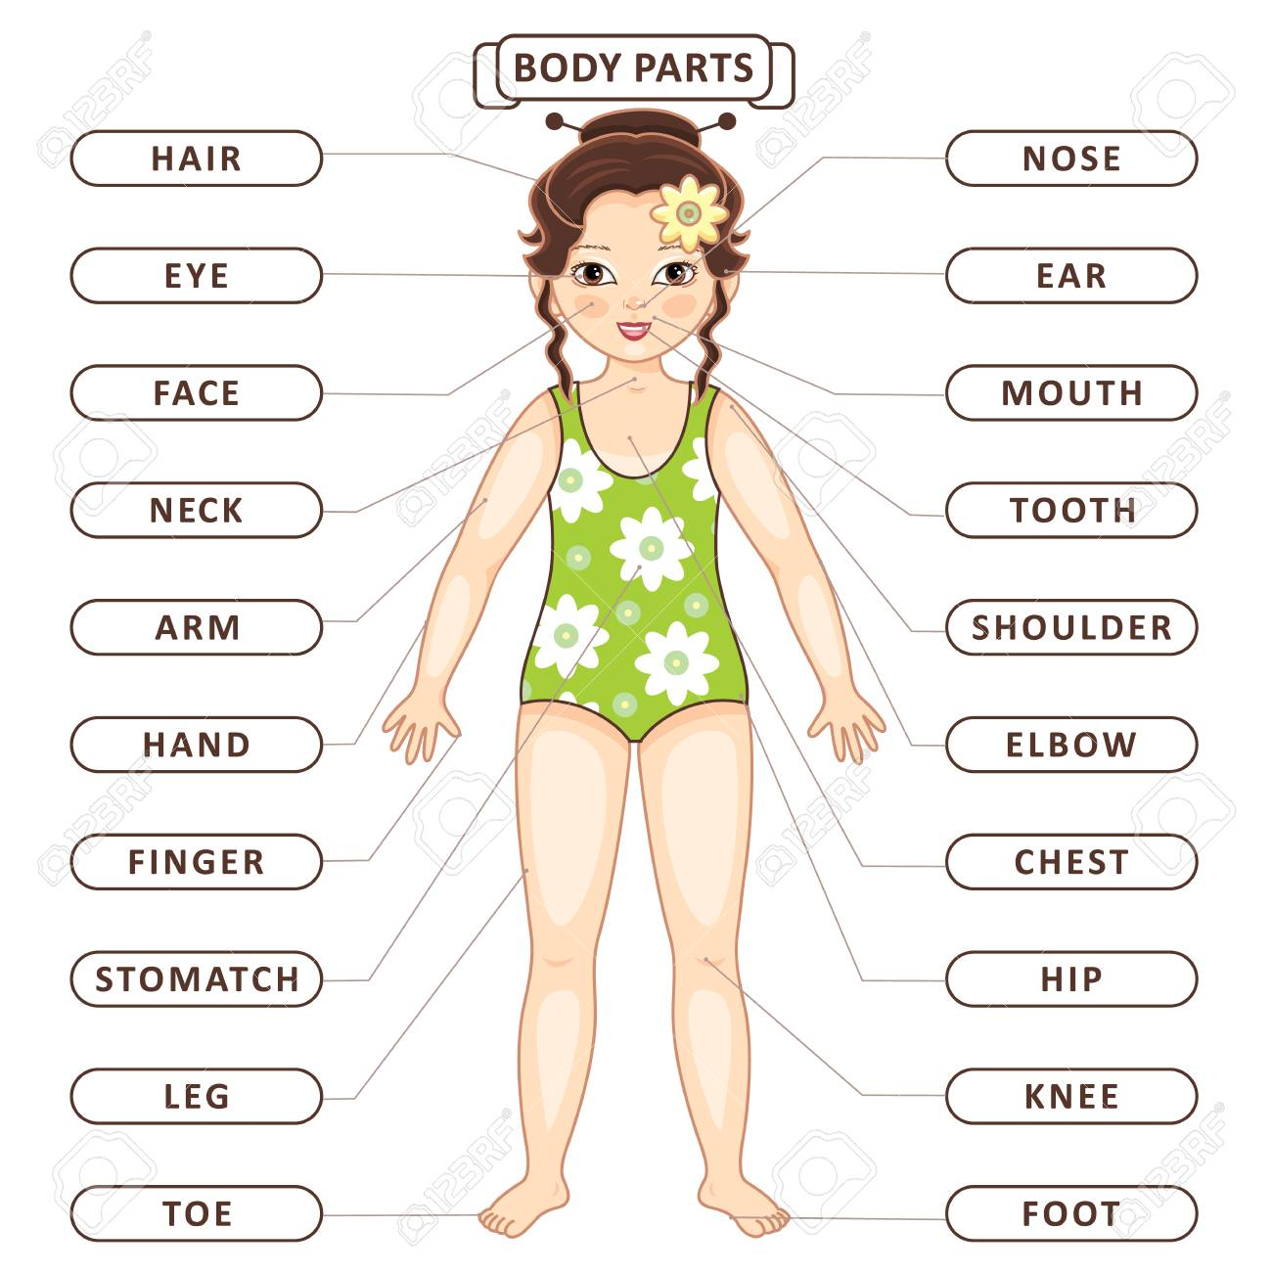

Picture 5 <https://www.clipart.email/list/body-parts/>

1. Hair: __________
2. Eye: __________
3. Face: _________
4. Neck: _________
5. Arm: __________
6. Hand: _________
7. Finger: ________
8. Stomach: ______
9. Leg: __________
10. Toe: ___________
11. Nose: __________
12. Ear: ____________
13. Mouth: __________
14. Tooth: ___________
15. Shoulder: _________
16. Elbow: ____________
17. Elbow: _______________
18. Hip: _________________
19. Knee: ________________
20. Foot: _________________