|  |  |  |  |  |
| --- | --- | --- | --- | --- |
| **ÁREA:** Humanidades, Lengua Castellana e Idioma Extranjero. | | | **DOCENTE:** | |
| **ASIGNATURA:** Inglés. | | | **ESTUDIANTE:** | |
| **GRADO:** BÁSICO | **NIVEL:** 2 | **ANEXO:** 01 | **TIEMPO:** | **FECHA: ____/ ____ / ____** |

1. Translate the text to Spanish; lea y traduzca)

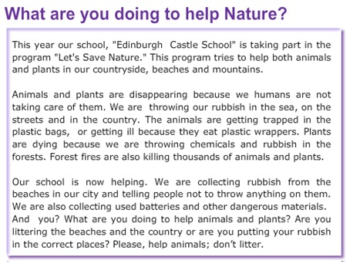

Picture 3 <https://brainly.lat/tarea/4209030>

1. Make a word list for verbs, connectors, nouns and adjectives on the following table (extraiga los verbos, conectores, sustantivos y adjetivos de la lectura anterior y ordénelos en la lista)

|  |  |  |  |
| --- | --- | --- | --- |
| **VERBS** | **CONNECTORS** | **NOUNS** | **ADJECTIVES** |
| Is | To | Year | Dangerous |
|  |  |  |  |
|  |  |  |  |
|  |  |  |  |
|  |  |  |  |
|  |  |  |  |
|  |  |  |  |
|  |  |  |  |
|  |  |  |  |
|  |  |  |  |
|  |  |  |  |
|  |  |  |  |
|  |  |  |  |