|  |  |  |  |  |
| --- | --- | --- | --- | --- |
| **ÁREA:** Humanidades, Lengua Castellana e Idioma Extranjero. | | | **DOCENTE:** | |
| **ASIGNATURA:** Inglés. | | | **ESTUDIANTE:** | |
| **GRADO:** BÁSICO | **NIVEL:** 2 | **ANEXO:** 5 | **TIEMPO:** | **FECHA: ____/ ____ / ____** |

1. **According to the video and the images;** escriba el significado de acuerdo al video visto y las imágenes

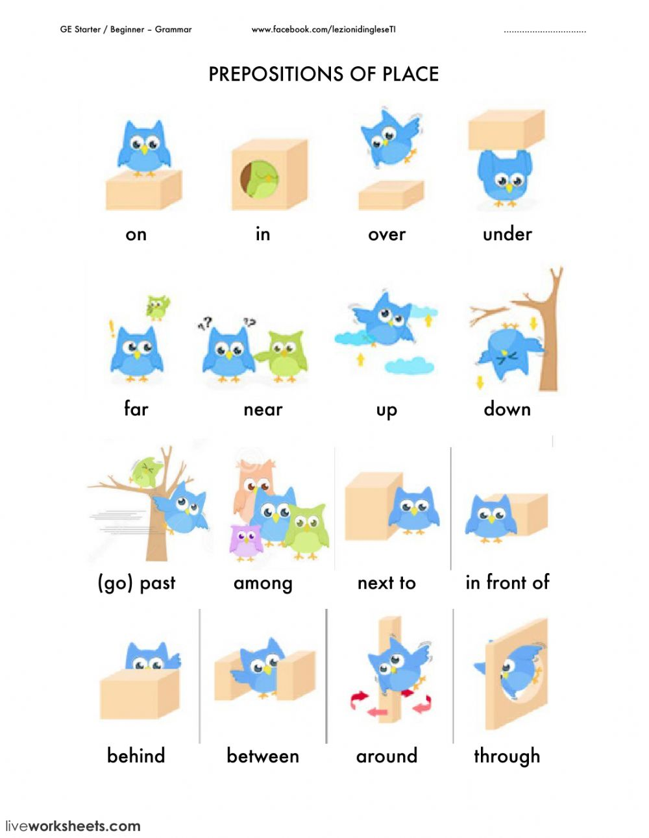

* on ____________
* in _____________
* over __________
* under _________
* far ____________
* near ___________
* up ______________
* down ___________
* among __________
* next to __________
* in front of ______
* behind ___________
* between _________
* around __________
* through _________
* at the corner
* __________________
* at the left
* __________________
* at the right
* __________________

Picture 7 [https://repasandoingles.weebly.com/9642- posters/prepositions-of-place](https://repasandoingles.weebly.com/9642-%20%20%20posters/prepositions-of-place)