|  |  |  |  |  |
| --- | --- | --- | --- | --- |
| **ÁREA:** Humanidades, Lengua Castellana e Idioma Extranjero. | | | **DOCENTE:** | |
| **ASIGNATURA:** Inglés. | | | **ESTUDIANTE:** | |
| **GRADO:** CLEI III | **MÓDULO:** 3 | **ANEXO: 7** | **TIEMPO:** | **FECHA: ____/ ____ / ____** |

**UNDERSTANDING AND VISUAL COMPREHENSION**

* ACCORDING TO THE PICTURES OF CAT AND DOG ANSWER:(prepositions of place feedback; *watch the video* before answering). De acuerdo con las imágenes del perro y el gato y después de observar el siguiente video con detenimiento; responda a las preguntas eligiendo la opción correcta.

[**https://youtu.be/BjFZbns1ZR0**](https://youtu.be/BjFZbns1ZR0)

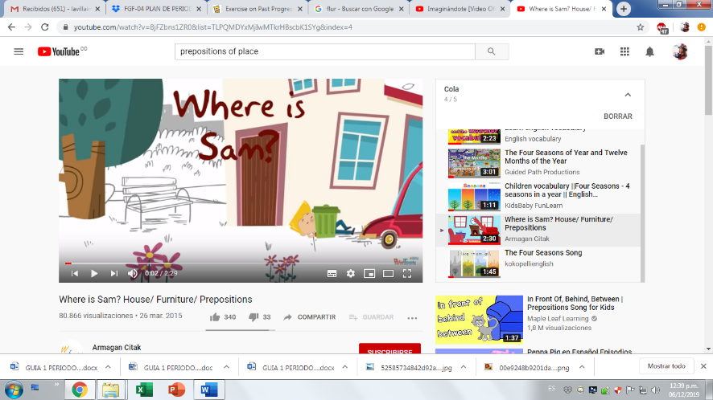

Picture 21

**Look at the picture and answer the questions** (debe entender las preguntas, de lo contrario utilizar el diccionario)

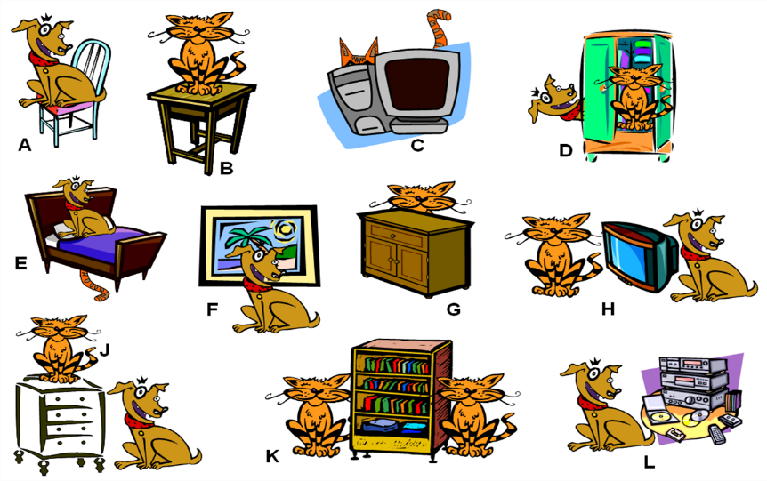

Picture 22<https://sweetsiobhan.wordpress.com/2017/08/29/prepositions-of-place/>

* **In picture number one (A) the chair is:**

1. Over the dog
2. On the dog
3. Under the dog
4. Between the dog

* **In picture number two (B) the cat is:**

1. Over the table
2. On the table
3. In the table
4. Beside the table

* **In picture number three (C) the cat is:**

1. Beside the computer
2. Before the computer
3. Between the computer
4. Behind the computer

* **In picture number four (D) the cat is:**

1. In the closet
2. On the closet
3. At the corner of the closet
4. At the right of the dog

* **In picture number five (E) the pillow is:**

1. On the bed
2. Under the dog
3. Between dog and bed
4. On the cat

* **In picture number six (F) the Dog is:**

1. Opposite the picture
2. Behind of the picture
3. Across the picture
4. On the floor

* **In picture number eight (H) the television set is:**

1. In the center of the animals
2. Between cat and dog
3. Behind cat and dog
4. Next to the animals

* **In picture number nine (J) the dog is:**

1. At the right side of the cat
2. At the corner of the picture
3. At the left side of the cat
4. At the right of the night table

* **In picture number 10 (K) the books are:**

1. In the bookshelf
2. On the table
3. In the bookshelf
4. Inside the closet

* **In picture number eleven (L) the remote control is:**

1. In the center of cassetes
2. Between two cassettes
3. Between the cassettes
4. Between a cd and a cassette