ÁREA: Humanidades, Lengua Castellana e Idioma Extranjero. |  |  | DOCENTE:
ASIGNATURA: Inglés. |  |  | ESTUDIANTE:
GRADO: CLEI III | MÓDULO: 4 | ANEXO: 01 | TIEMPO: | FECHA: ____/ ____ / ____

READING COMPREHENSION

- Look at this conversation and practice your English with the possessive adjectives; later, read Shakira´s description (lea la conversación y analice la descripción de la artista Shakira)
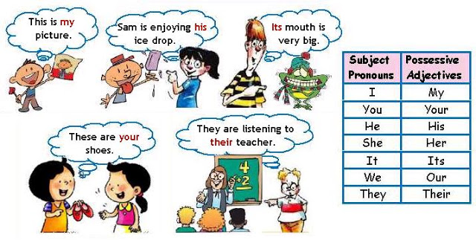

Picture 3 http://virmariselt.blogspot.com/2017/02/my-your-his-her-possessive-adjectives.html

Shakira (comprehension)
Shakira has got a pretty face; she has a long blonde hair and her body is amazing.
Shakira´s voice has been recognized all around the world and her movements are so famous too.
Her nationality is Colombian and her personality is very special.
Shakira´s face is beautiful; her age is 43 and her appearance is really young and attractive due to her healthy life habits.
Picture 4 https://www.pinterest.pt/pin/407716572500404842/

Glossary: glosario

- Amazing: Maravilloso
- Has been: Ha sido
- Age: edad
- Due to: debido a…

