|  |  |  |  |  |
| --- | --- | --- | --- | --- |
| **ÁREA:** Humanidades, Lengua Castellana e Idioma Extranjero. | | | **DOCENTE:** | |
| **ASIGNATURA:** Inglés. | | | **ESTUDIANTE:** | |
| **GRADO:** CLEI III | **MÓDULO:** 4 | **ANEXO:** 02 | **TIEMPO:** | **FECHA: ____/ ____ / ____** |

**GRAMMAR AND WRITING**

Observe los personajes y exprese sus estados de ánimo; investigue en el siguiente link [**https://blogs.transparent.com/spanish/spanish-vocabulary-emotions-emociones/**](https://blogs.transparent.com/spanish/spanish-vocabulary-emotions-emociones/) y añada a su descripción los atuendos que cada uno de los personajes utiliza y sus características físicas más llamativas y un verbo en pasado.

**Example**: *Johnson* ***wore*** *a pink T-shirt and a blue jean;* ***his*** *face Is circular; he is a* ***short*** *handsome boy; Johnson* ***wore*** *a nice coat Yesterday; he was thoughtful.*

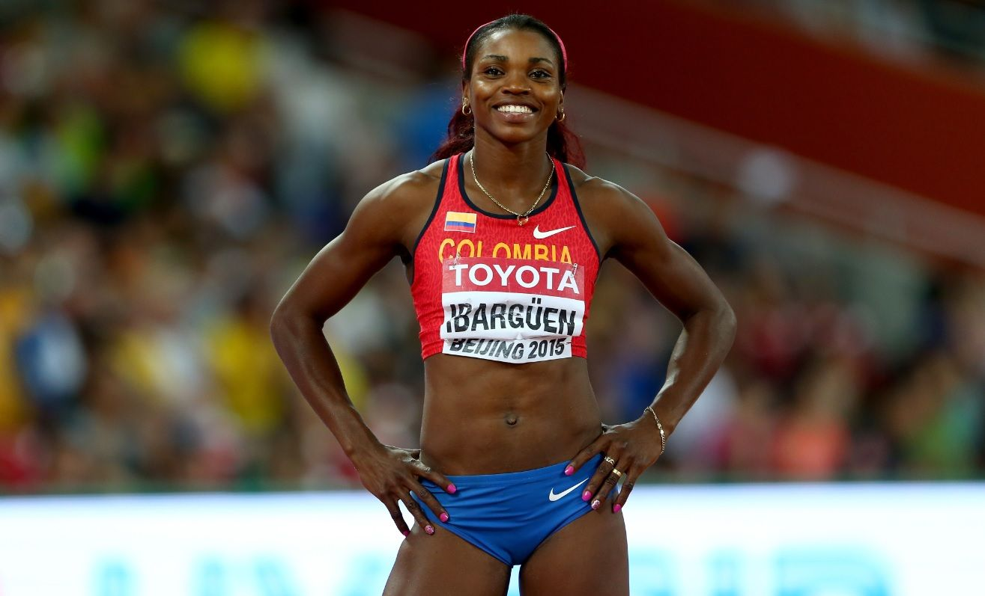

**Katherine**

___________________________________

___________________________________

___________________________________

___________________________________

___________________________________

___________________________________

Picture 5 <https://www.mundotkm.com/co/famosos/46348/el-curioso-vallenato-que-escucha-caterine-ibarguen-para-motivarse-antes-de-cada-competencia>

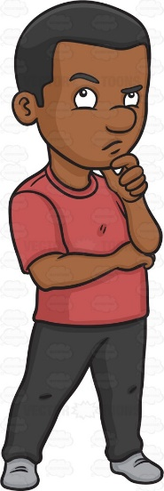

**Johnson**

___________________________________

___________________________________

___________________________________

___________________________________

___________________________________

___________________________________

Picture 6 <https://www.clipart.email/clipart/african-person-clipart-20147.html>

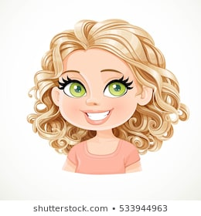

**Britany**

___________________________________

___________________________________

___________________________________

___________________________________

___________________________________

Picture 7 <https://www.shutterstock.com/es/search/cartoon+girl+blonde?search_source=base_related_searches&section=1&noid=1&ref_context=keyword>