|  |  |  |  |  |
| --- | --- | --- | --- | --- |
| **ÁREA:** Humanidades, Lengua Castellana e Idioma Extranjero. | | | **DOCENTE:** | |
| **ASIGNATURA:** Inglés. | | | **ESTUDIANTE:** | |
| **GRADO:** CLEI III | **MÓDULO:** 4 | **ANEXO:** 04 | **TIEMPO:** | **FECHA: ____/ ____ / ____** |

**POOL OF EXERCISES (application)**

1. Practiquemos todo lo visto con anterioridad en este mix de ejercicios de aplicación.

**Was or Were; let´s watch this video and learn (observe el siguiente video a cerca del pasado progresivo).**

[**https://youtu.be/etvW0FOD_so**](https://youtu.be/etvW0FOD_so)

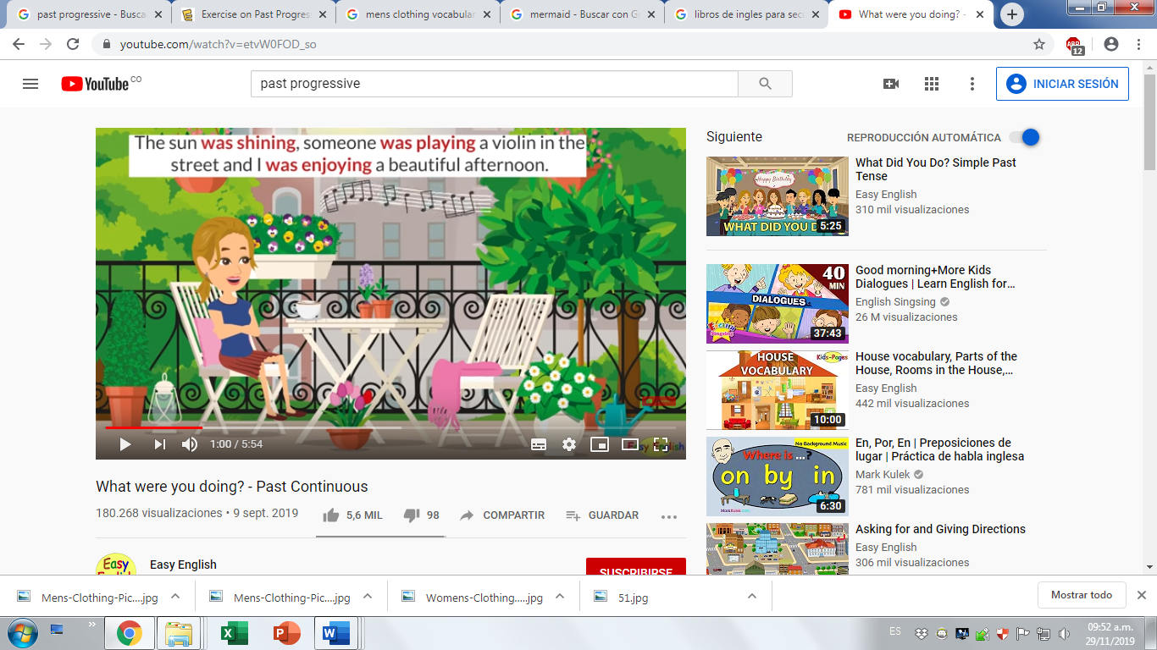

Picture 10

**Decide whether to use 'was' or 'were'**. (decida si usa was o were en el lineal)

* Boris _________ learning English.
* They _________ swimming in the lake.
* Your father _________ repairing the car.
* I _________ reading a magazine.
* You _________ packing your bag.
* My friends ________ watching the match on TV.
* It ________ raining.
* The dog _______ barking.
* The children ________ brushing their teeth.
* Anne and Maureen _______ singing a song.

**Positive Sentences**

Yesterday at 3 pm the following people were in the middle of an action.  
Write positive sentences in past progressive.(Escriba frases afirmativas)

* you / play / cards _________________________________
* Alice / walk / around the lake ______________________________
* Caron / listen / to the radio ________________________________
* we / read / a book about Australia _____________________________
* Linda / look for / her ring ____________________________________
* Fiona and Sam / visit / the castle _______________________________
* Ben / wash / the car __________________________________
* Kim and I / wait / in the park __________________________________
* My sister / feed / the birds ____________________________________
* Greg and Phil / count / their money _____________________________

**Negative Sentences**

Somebody believes that yesterday at 3 pm the following people were in the middle of an action. That cannot be, however, as yesterday at 3 pm these people were not doing those things.  
Write negative sentences in past progressive. (Elabore frases negativas)

* Sarah and Luke / not / work __________________________________
* Mister Miller / not / teach / chemistry ___________________________
* Barry / not / drive / a lorry ____________________________________
* Mandy / not / have / lunch ____________________________________
* Albert / not / play / tennis _____________________________________
* Taylor and Bob / not / cycle / home _____________________________
* Annie / not / clean / the table __________________________________
* Benjamin / not / write / an e-mail _______________________________
* Jane / not / exercise / in the gym _______________________________
* Robert / not / buy / flowers ____________________________________