|  |  |  |  |  |
| --- | --- | --- | --- | --- |
| **ÁREA: Humanidades lengua castellana e idioma extranjero** | | | **DOCENTE:** | |
| **ASIGNATURA:** Inglés | | | **ESTUDIANTE:** | |
| **GRADO:** CICLO 3 | **MÓDULO: 1** | **ANEXO:** 2 | **TIEMPO:** | **FECHA: ____/ ____ / ____** |

**WORK CLASS**

1. Has or have…
2. She_____long hair
3. The boy______a kite
4. He______hungry
5. He_______a puzzle
6. The dog______a bone
7. The baby_____hungry
8. The boy______sad
9. The cat______white
10. Tom________ books
11. The man_______fat
12. Choose the correct word.
13. Short (Alto/gordo/bajo)
14. Skinny (Gordo/bajo/flaco)
15. Scruffy (Desaliñado/limpio/elegante)
16. Slender ( Corpulante/esbelto/pequeño)
17. Tanned (Flaco/bronceado/blanco9)
18. Describe the following famous characters by using verb TO-BE; verb TO HAVE; Possessive noun; aphostrophe.

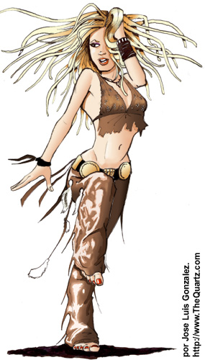

Shakira

______________________________ ______________________________

______________________________ ______________________________

______________________________ ______________________________

______________________________ ______________________________

______________________________

Leonel Messi

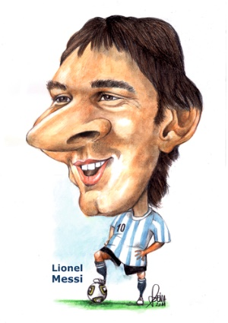

______________________________ ______________________________

______________________________ ______________________________

______________________________ ______________________________

______________________________ ______________________________

______________________________ ______________________________

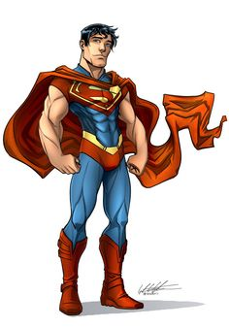Superman

______________________________ ______________________________

______________________________ ______________________________

______________________________ ______________________________

______________________________ ______________________________

______________________________ ______________________________

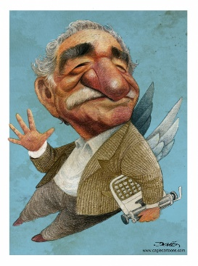 Gabriel García Márquez

______________________________ ______________________________

______________________________ ______________________________

______________________________ ______________________________

______________________________ ______________________________

______________________________ ______________________________

Maluma



 

 

 

 