|  |  |  |  |  |
| --- | --- | --- | --- | --- |
| **ÁREA:** Humanidades Lengua Castellana e Idioma Extranjero | | | **DOCENTE:** | |
| **ASIGNATURA:** Inglés | | | **ESTUDIANTE:** | |
| **GRADO:** Ciclo V | **MÓDULO:** 2 | **ANEXO: 1** | **TIEMPO:** | **FECHA: ____/ ____ / ____** |

1. **Read Carefully.**

*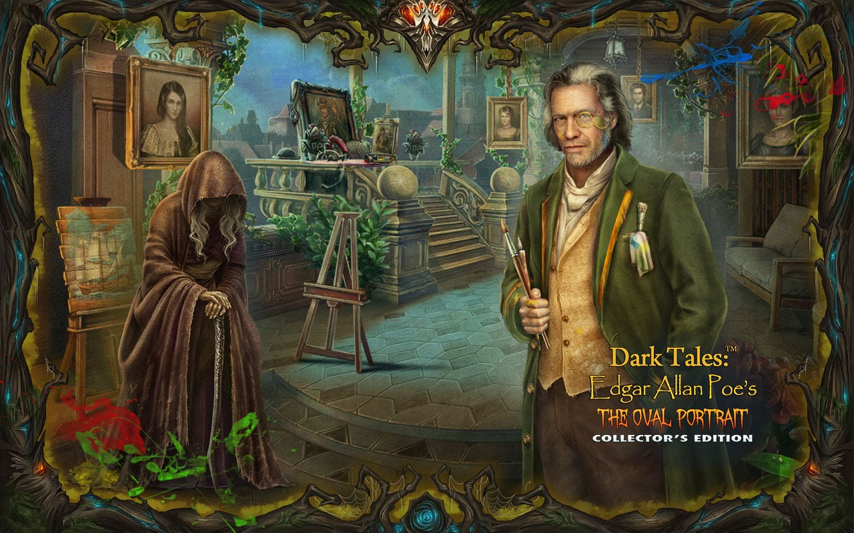***A LOVE STORY...**

*Love is the main objective we come for to this world; that´s what People in India say; but sometimes**Love becomes in trouble, sometimes people do not know how to express love or sometimes it turns into a kind of illness or sometimes people forget love for occupations and passions they have, finally they realize they had a great opportunity to share their lives with other person, but suddenly it´s too late…*

Picture 2 <https://rinconensoledad.blogspot.com/2018/09/dark-tales-14-edgard-allan-poes-oval.html>

Yes, she was happy. Until that[**evil day**](http://www.cuentoseningles.com.ar/shortstories/northamerican/ovalportrait.html) when she saw and loved the painter of her portrait. They were married. But, [**sadly**](http://www.cuentoseningles.com.ar/shortstories/northamerican/ovalportrait.html), he already had a wife: his work. His painting was more important to him than anything in the world.

Before, she was all light and smiles. She loved everything in the world. Now she loved all things but one: her husband's work. His painting was her only enemy; and she began [**to hate**](http://www.cuentoseningles.com.ar/shortstories/northamerican/ovalportrait.html) the paintings that [**kept her husband away**](http://www.cuentoseningles.com.ar/shortstories/northamerican/ovalportrait.html) from her. And so it was a terrible thing when he told her that he wanted to paint his young wife's portrait.

For weeks, she sat in the tall, dark room while he worked. He was a [**silent**](http://www.cuentoseningles.com.ar/shortstories/northamerican/ovalportrait.html) man, always working, always lost in his [**wild, secret dreams**](http://www.cuentoseningles.com.ar/shortstories/northamerican/ovalportrait.html). She sat still always smiling, never moving while he painted her hour after hour, day after day. He did not see that she was [**growing weaker**](http://www.cuentoseningles.com.ar/shortstories/northamerican/ovalportrait.html) with every day. He never noticed that she was not healthy any more, and not happy any more. The change was happening in front of his eyes, but he did not see it.

But she [**went on**](http://www.cuentoseningles.com.ar/shortstories/northamerican/ovalportrait.html) smiling. She never stopped smiling because she saw that her husband, who was now very famous, enjoyed his work so much. He worked day and night, painting the portrait of the woman he loved. And as he painted, the woman who loved him grew slowly weaker and [**sadder**](http://www.cuentoseningles.com.ar/shortstories/northamerican/ovalportrait.html).

Several people saw the half-finished picture. They told the painter how wonderful it was, speaking softly as he worked. They said the portrait showed how much he loved his beautiful wife. Silently, she sat in front of her husband and his visitors, hearing and seeing nothing now.

The work was [**coming near an end**](http://www.cuentoseningles.com.ar/shortstories/northamerican/ovalportrait.html). [**He did not welcome visitors**](http://www.cuentoseningles.com.ar/shortstories/northamerican/ovalportrait.html) in the room any more. A terrible fire was burning inside him now. He was wild, almost [**mad**](http://www.cuentoseningles.com.ar/shortstories/northamerican/ovalportrait.html) with his work. His eyes almost never left the painting now, even to look at his wife’s face. Her face was as white as snow. The painter did not see that the colours he was painting [**were no longer there**](http://www.cuentoseningles.com.ar/shortstories/northamerican/ovalportrait.html) in her real face.

Many more weeks passed until, one day, in the middle of winter, he finished the portrait. He touched the last paint on to her lips; he put the last, thin line of colour on an eye; then he stood back and looked at the finished work.

As he looked, he began [**to shake**](http://www.cuentoseningles.com.ar/shortstories/northamerican/ovalportrait.html). All colour left his face. With his eyes on the portrait, he cried out to the world: ‘This woman is not made of paint! She is alive!’ Then he turned [**suddenly**](http://www.cuentoseningles.com.ar/shortstories/northamerican/ovalportrait.html) to look at the woman he loved so much…… She was **dead.**